**Experiment No: 1**

**Date : 10/02/2025**

**Familiarization of DDL Commands**

Data Definition Language (DDL) - These SQL commands are used for creating, modifying, and dropping the structure of database objects. The commands are CREATE, ALTER, DROP, RENAME, and TRUNCATE.

A. Consider the database for a college. Write SQL commands to implement the following:

1. Create a database

>> create database 24mca48;

2. Select the current database

>> use 24mca48;

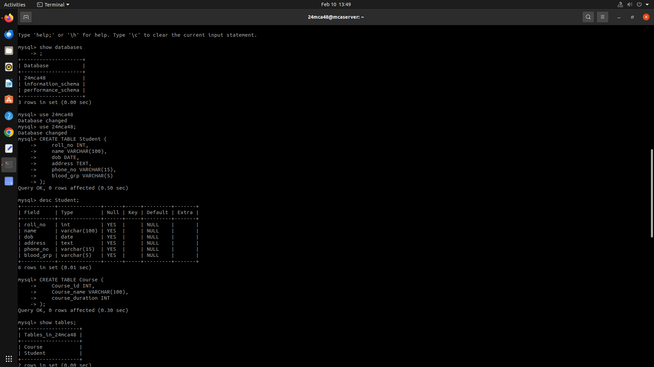

3. Create the following tables:

a) Student (roll_no integer, name varchar, dob date, address text, phone_no varchar, blood_grp varchar)

>> create table student(roll_no int,name varchar(30),dob date,address varchar(255),phone_no varchar(11),blood_grp varchar(6));

b) Course (Course_id integer, Course_name varchar, course_duration integer)

>> create table course(course_id int not null,course_name varchar(20),course_duration int);

4. List all tables in the current database.

>> show tables;



5. Display the structure of the Student table.

>> describe student;



6. Drop the column blood_grp from Student table.

>> alter table student drop column blood_grp;

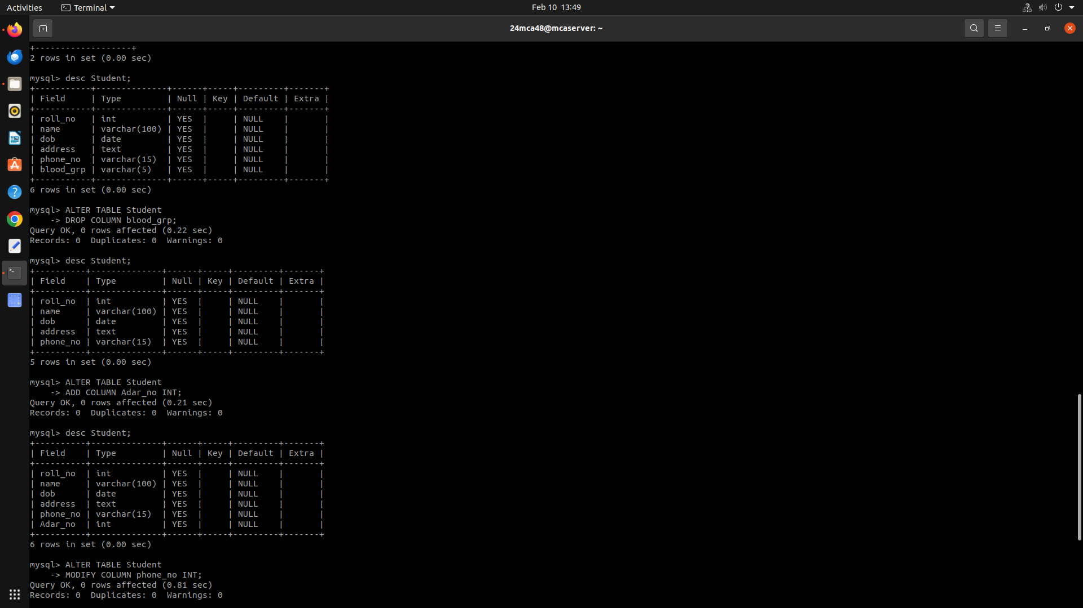

7. Add a new column Adar_no with domain number to the table Student.

>> alter table student add column Adar_no int;



8.

8.Change the datatype of phone_no from varchar to int

>> alter table student modify phone_no int;

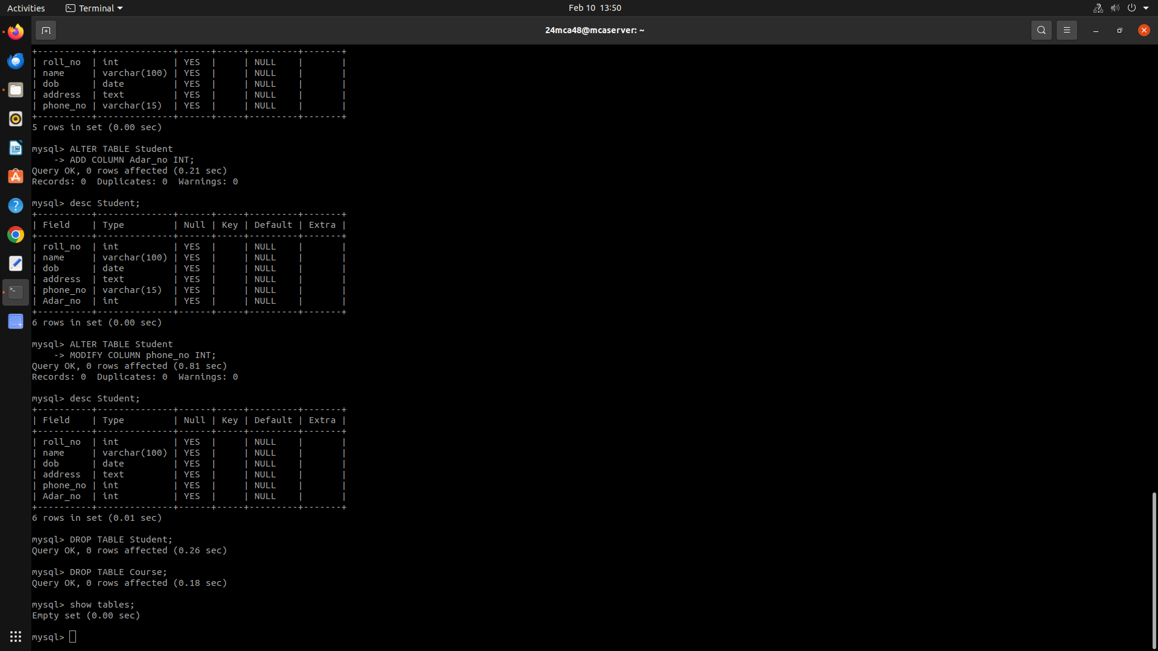9. Drop the tables.

>> drop table student;

10. Delete the database.

>>Drop database 24mca48;

B. Consider the database for an organization. Write SQL commands to implement the following:

1. Create a database

>> create database 24mca48;

2. Select the current database

>> use 24mca48;



3. Create the following tables:

a) Employee (emp_no varchar, emp_name varchar, dob date, address text, mobile_no integer, dept_no varchar, salary integer)

>> create table Employee(emp_no varchar(50),emp_name varchar(100),dob date,address varchar(255),mobile_no int,dept_no varchar(50),salary int);

b) Department (dept_no varchar, dept_name varchar, location varchar)

>> create table department(dept_no varchar(50),dept_name varchar(100),location varchar(100));

4. List all tables in the current database.

>> show tables;

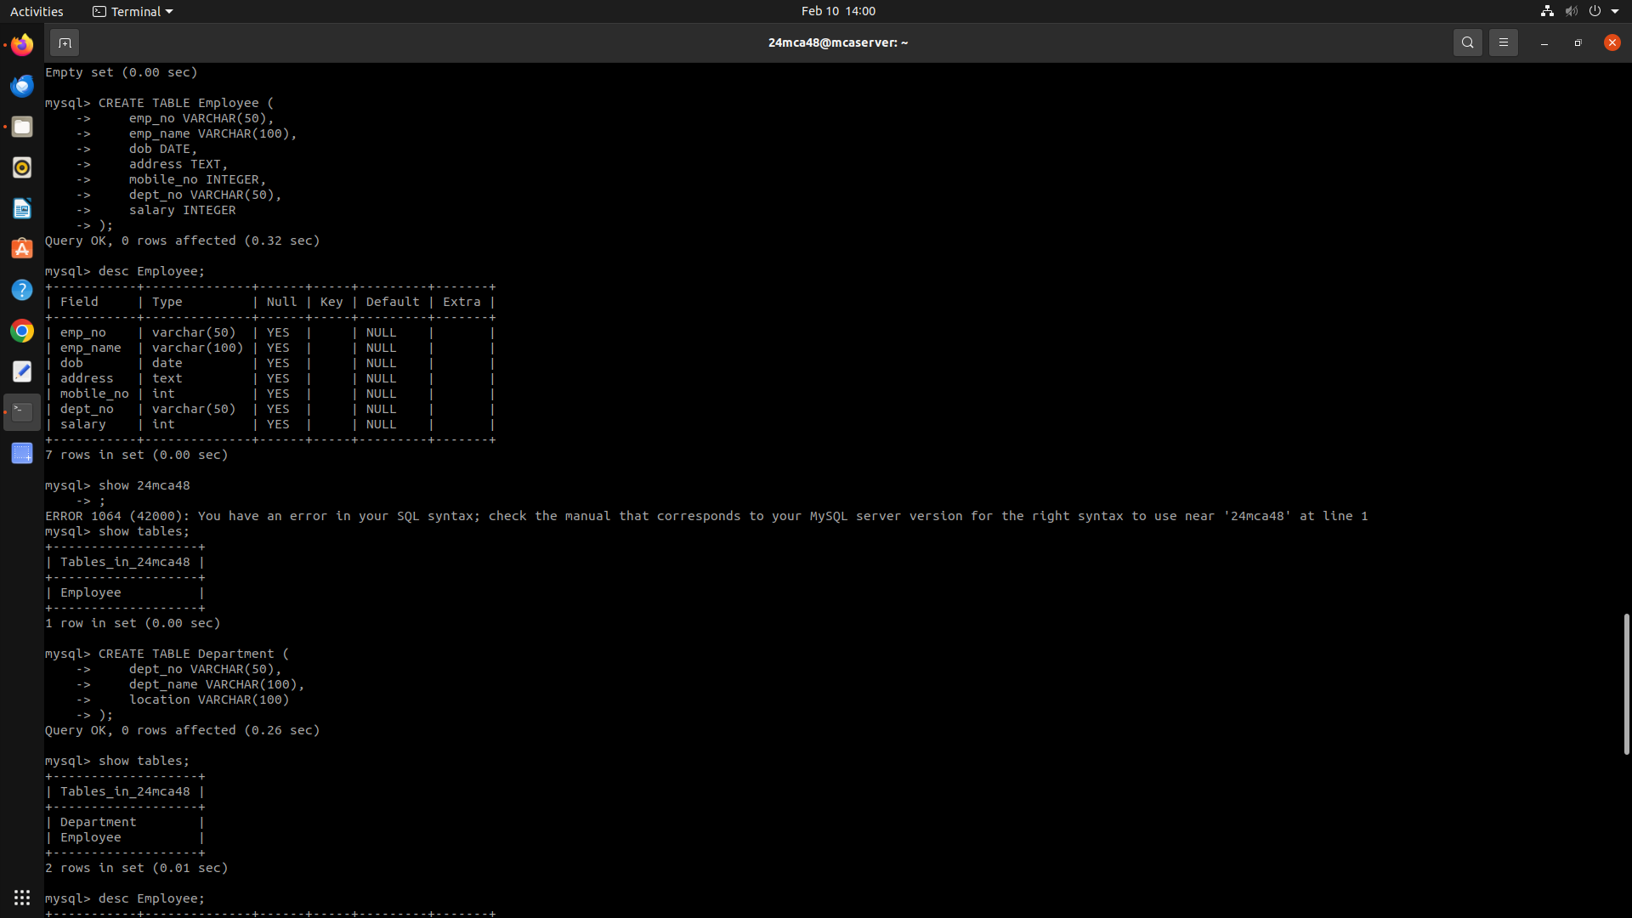

5. Display the structure of the Employee table and Department table.

>> describe department;

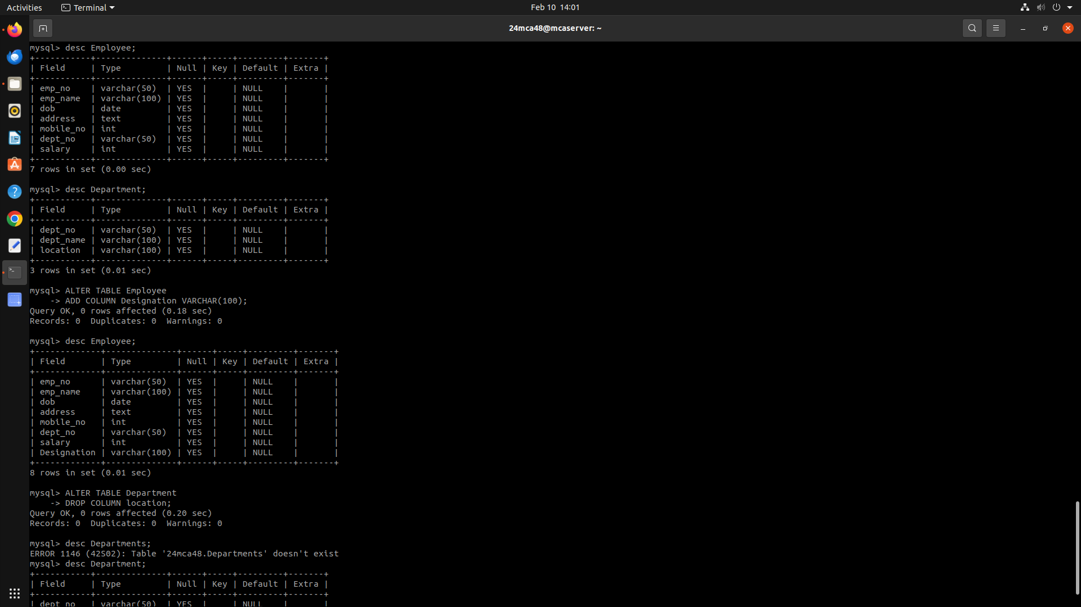

>> describe Employee;

6. Add a new column ‘Designation’ to the table Employee.

>> alter table employee add column Designation varchar(100);



7. Drop the column ‘location’ from Department table.

>> alter table Department drop column location;



**Experiment No: 2**

**Date : 10/02/2025**

**Familiarization of SQL Constraints.**

1. Create new table Persons with attributes PersonID (integer, PRIMARY KEY), Name (varchar , NOT NULL), Aadhar (Number, NOT NULL, UNIQUE), Age (integer , CHECK>18).

>> create table Persons(PersonID int primary key,Name varchar(255) not null,aadhar int not null unique,age int,check(age>18));

2. CREATE TABLE Orders with attributes OrderID (PRIMARY KEY), OrderNumber(NOT NULL) and PersonID( set FOREIGN KEY on attribute PersonID referencing the column PersonId of Person table)

>> create table Orders(OrderID int primary key,OrderNumber int not null varchar(255),person_id int,foreign key(PersonID)references persons(PersonID);

3. Display the structure of Persons tables.

>> describe Persons;

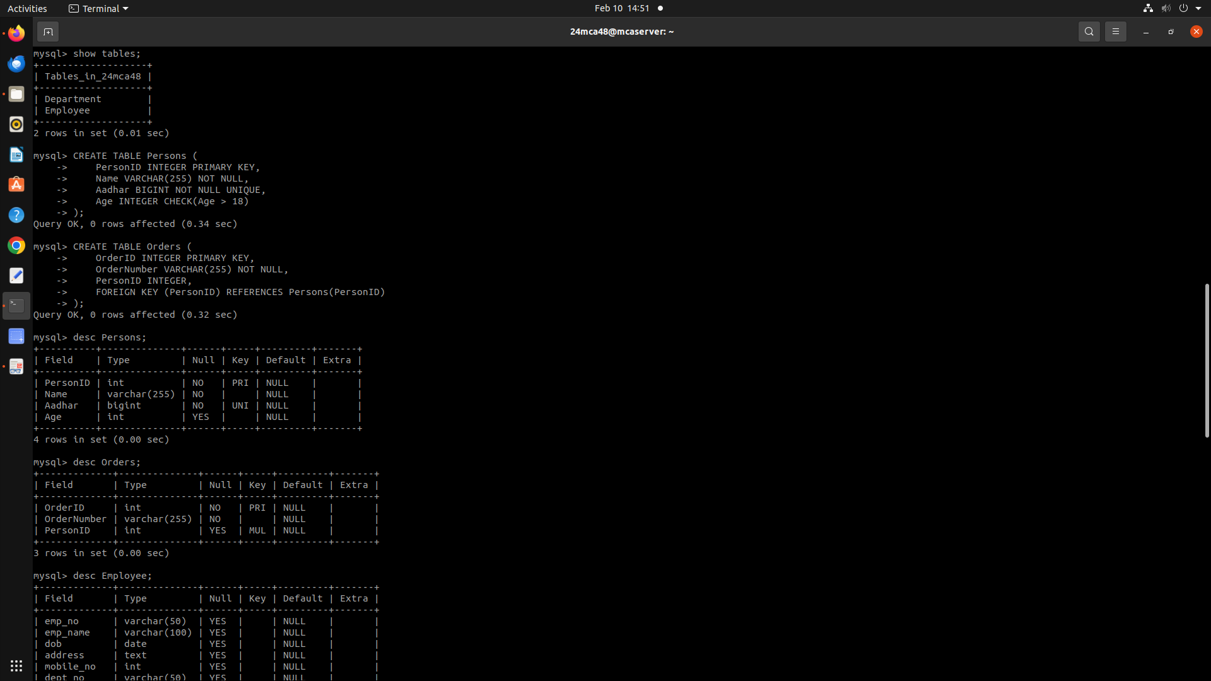

4. Display the structure of Orders tables.

>> describe Orders;



5. Add emp_no as the primary key of the table Employee.

>> alter table Employee modify column emp_no int primary key;

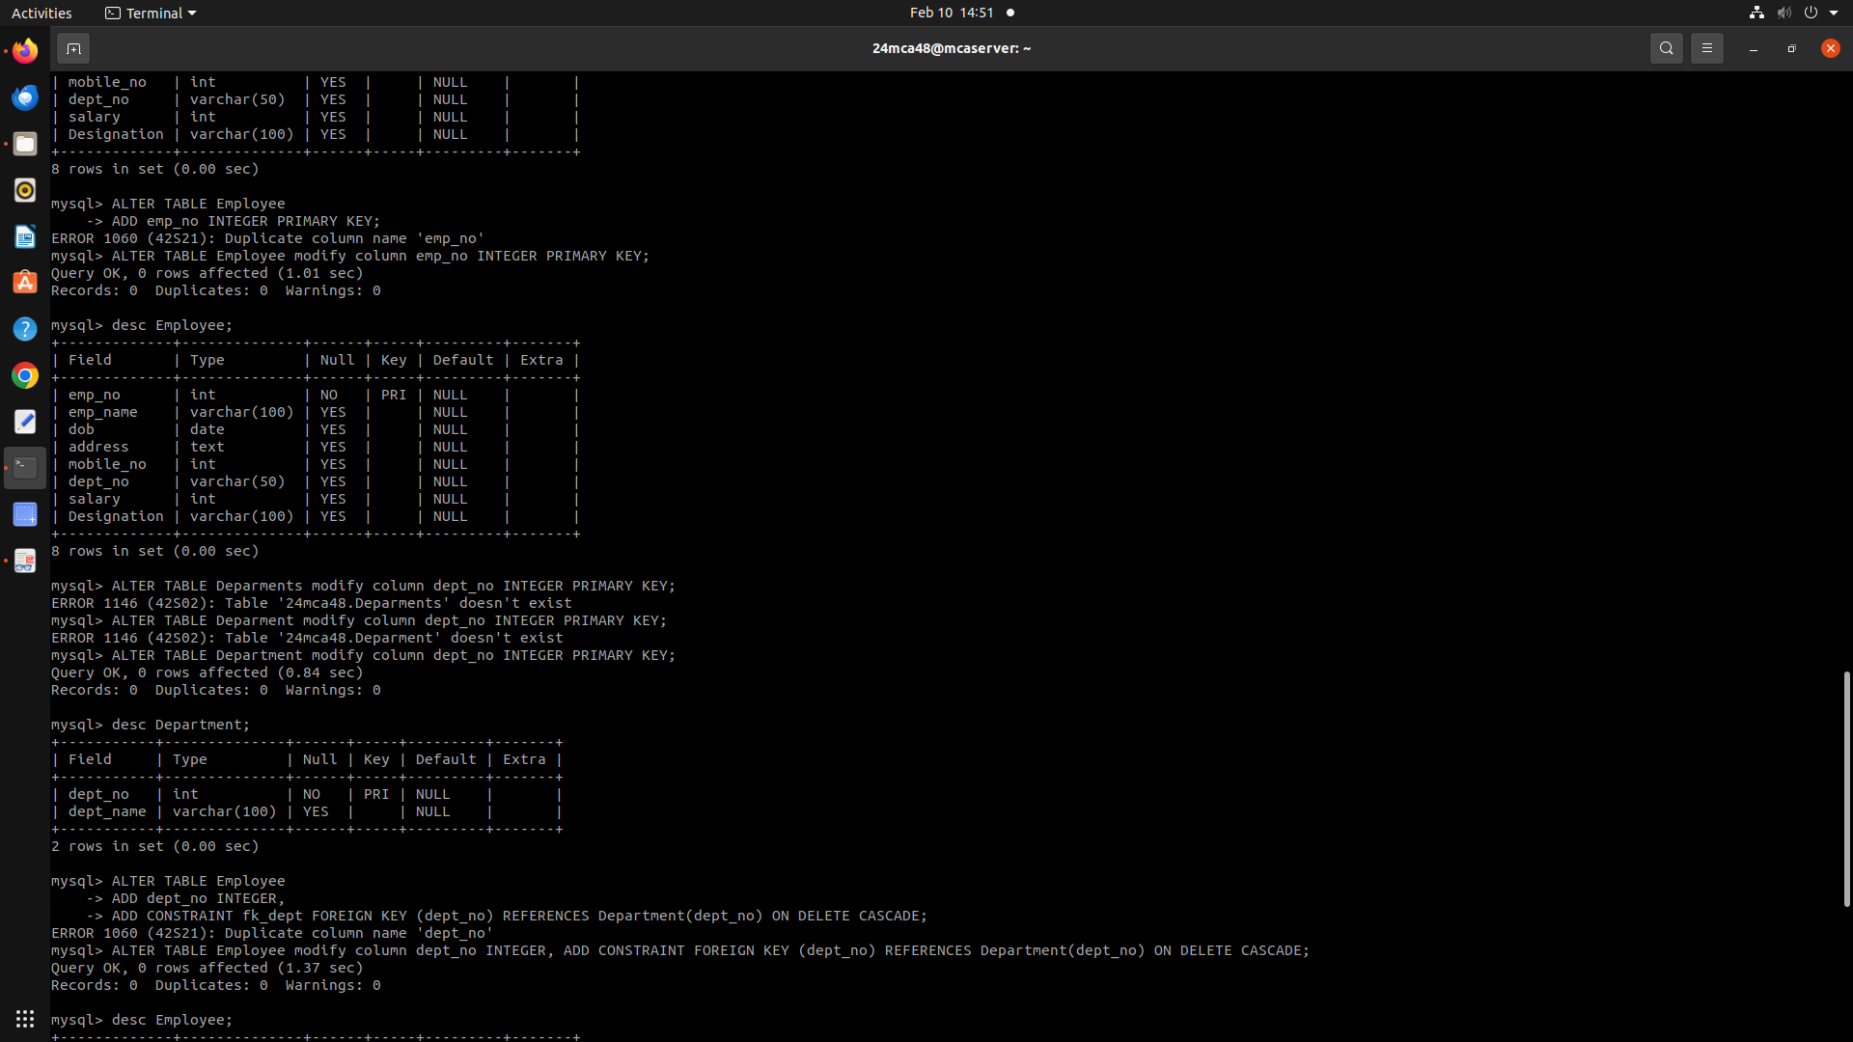

6. Add dept_no as the primary key of the table Department.

>> alter table department modify column dept_no int primary key;



7. Add dept_no in Employee table as the foreign key reference to the table Department with on delete cascade.

>> alter table Employee modify column dept_no integer, add constraint foreign key(dept_no)references Department(dept_no)on delete cascade;

8. Drop the primary key of the table Orders.

>> alter table orders drop primary key;

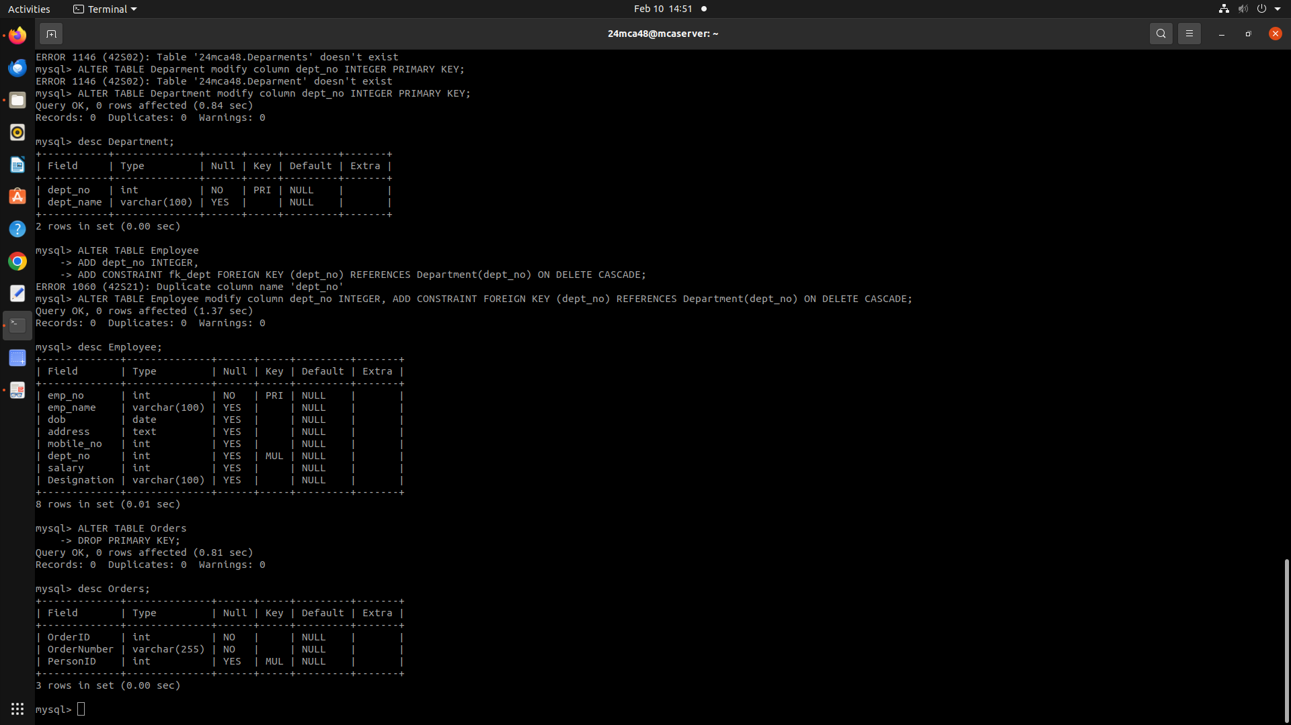

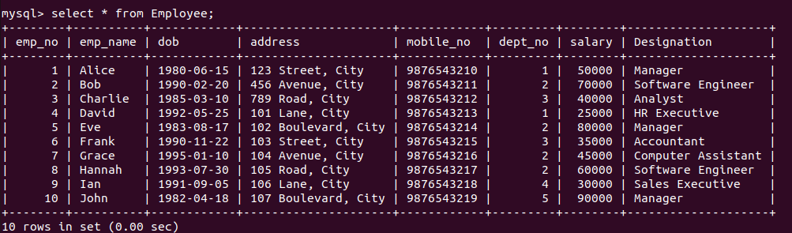**Experiment No: 3**

**Date : 17/02/2025**

**Familiarization of DML Commands**

1. Add at least 10 rows into the table Employee and Department.

>> INSERT INTO Department (dept_no, dept_name) VALUES (1, 'HR'),(2, 'IT'),(3, 'Finance'),(4, 'Marketing'),(5, 'Operations'),(6, 'Sales'),(7, 'Customer Support'),(8, 'Research & Development'),(9, 'Logistics'),(10, 'Administration');

>> INSERT INTO Employee (emp_no, emp_name, Designation, dept_no, salary, mobile_no, dob, address) VALUES (1, 'Alice', 'Manager', 1, 50000, 9876543210, '1980-06-15', '123 Street, City'),(2, 'Bob', 'Software Engineer', 2, 70000, 9876543211, '1990-02-20', '456 Avenue, City'),(3, 'Charlie', 'Analyst', 3, 40000, 9876543212, '1985-03-10', '789 Road, City'),(4, 'David', 'HR Executive', 1, 25000, 9876543213, '1992-05-25', '101 Lane, City'),(5, 'Eve', 'Manager', 2, 80000, 9876543214, '1983-08-17', '102 Boulevard, City'),(6, 'Frank', 'Accountant', 3, 35000, 9876543215, '1990-11-22', '103 Street, City'),(7, 'Grace', 'Computer Assistant', 2, 45000, 9876543216, '1995-01-10', '104 Avenue, City'),(8, 'Hannah', 'Software Engineer', 2, 60000, 9876543217, '1993-07-30', '105 Road, City'),(9, 'Ian', 'Sales Executive', 4, 30000, 9876543218, '1991-09-05', '106 Lane, City'),(10, 'John', 'Manager', 5, 90000, 9876543219, '1982-04-18', '107 Boulevard, City');

2. Display all the records from the above tables.

>> SELECT * FROM Employee;

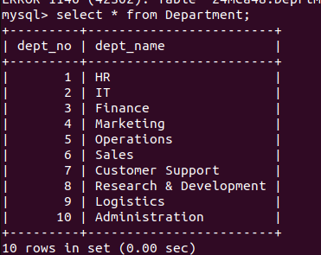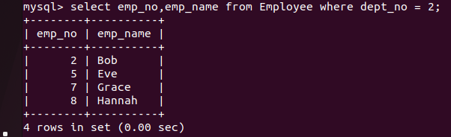>> SELECT * FROM Department;

>> select * from Employee;

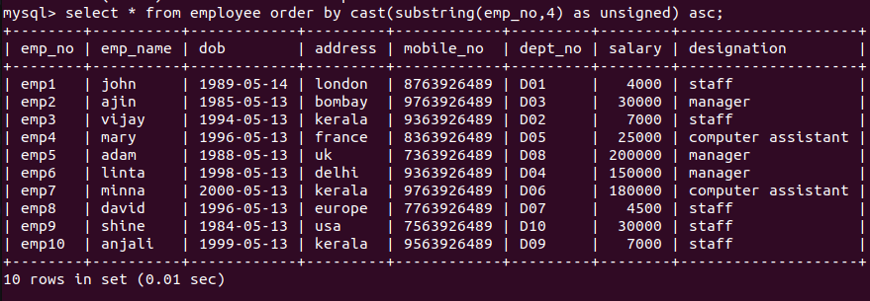

3. Display the emp_no and name of employees from department no ‘D02’.

>> select emp_no,emp_name from employee where dept_no=2;

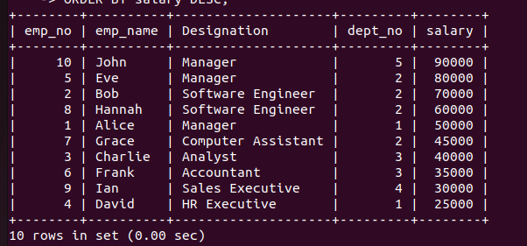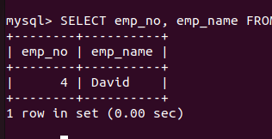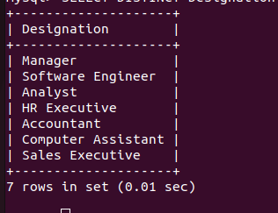4. Display emp_no, emp_name , designation, deptno and salary of employees in the descending order of salary.

>> select emp_no,emp_name,Designation,dept_no,salary from employee order by salary desc;

5. Display the emp_no , name of employees whose salary is between 2000 and 5000

>> select emp_no,emp_name from Employee where salary between 2000 and 5000;

6. Display the designations without duplicate values

>> select distinct Designation from Employee;

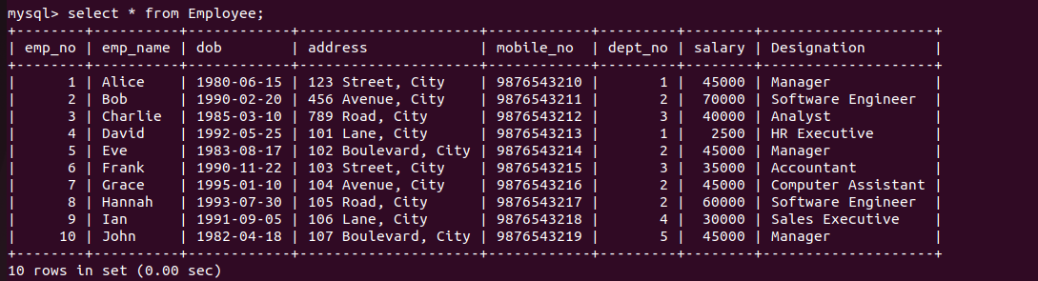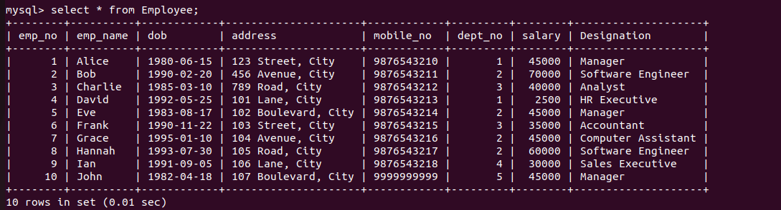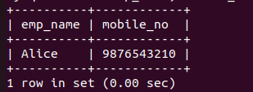7. Change the salary of employees to 45000 whose designation is 'Manager'

>> update Employee set salary='45000' where Designation='Manager';

8. Change the mobile number of employees named John

>> UPDATE Employee SET mobile_no = 9999999999 WHERE emp_name = 'John';

9. Delete all employees whose salary is equal to Rs.7000

>> delete from employee where salary='7000';

10. Retrieve the name, mobile number of all employees whose name start with “A”.

>> SELECT emp_name, mobile_no FROM Employee WHERE emp_name LIKE 'A%';

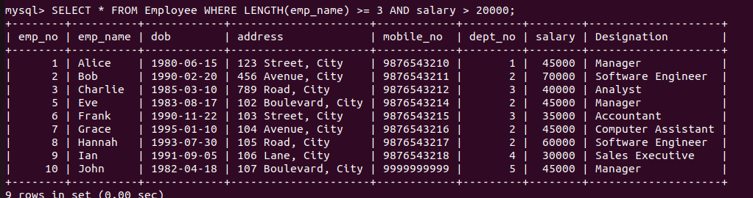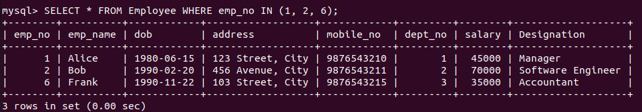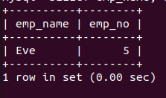11. Display the details of the employee whose name has at least three characters and salary greater than 20000.

>> SELECT * FROM Employee WHERE LENGTH(emp_name) >= 3 AND salary > 20000;

12. Display the details of employees with empid ‘emp1’, ‘emp2’ and ‘emp6’.

>> SELECT * FROM Employee WHERE emp_no IN (1, 2, 6);

13. Display employee name and employee id of those who have salary between 120000 and 300000.

>> SELECT emp_name, emp_no FROM Employee WHERE salary BETWEEN 120000 AND 300000;

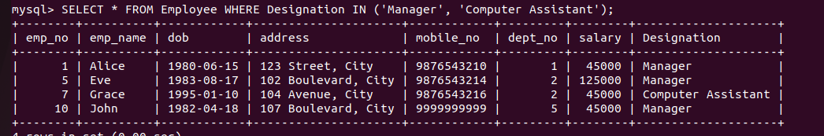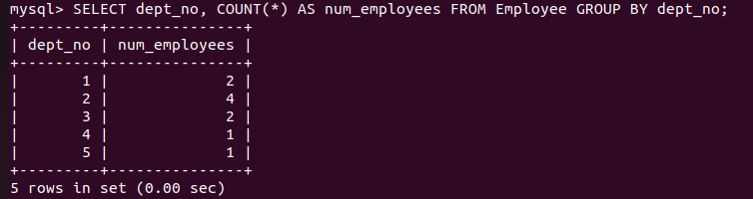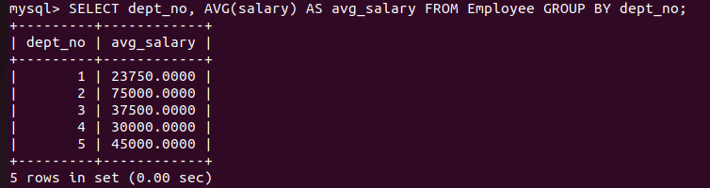14. Display the details of employees whose designation is ‘Manager’ or ‘Computer Assistant’.

>> SELECT * FROM Employee WHERE Designation IN ('Manager', 'Computer Assistant');

15. Displays how many employees work for each department.

>> SELECT dept_no, COUNT(*) AS num_employees FROM Employee GROUP BY dept_no;

16. Displays average salary of employees in each department.

>> SELECT dept_no, AVG(salary) AS avg_salary FROM Employee GROUP BY dept_no;

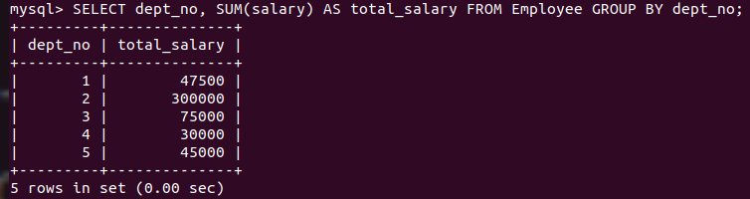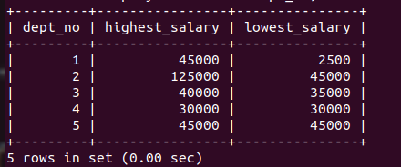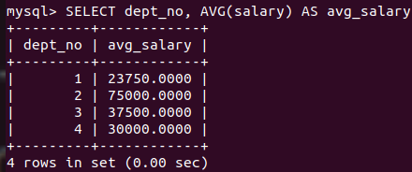17. Displays total salary of employees in each department.

>> SELECT dept_no, SUM(salary) AS total_salary FROM Employee GROUP BY dept_no;

18. Displays top and lower salary of employees in each department.

>> SELECT dept_no, MAX(salary) AS highest_salary, MIN(salary) AS lowest_salary FROM Employee GROUP BY dept_no;

19. Displays average salary of employees in all departments except department with department number ‘D05’.

>> SELECT dept_no, AVG(salary) AS avg_salary FROM Employee WHERE dept_no <> 5 GROUP BY dept_no;

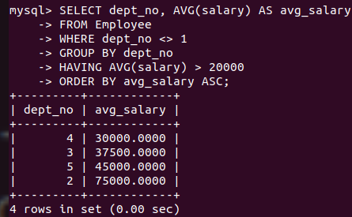20. Displays average salary of employees in all departments except department with department number ‘D01’ and average salary greater than 20000 in the ascending order of average salary.

>> SELECT dept_no, AVG(salary) AS avg_salary FROM Employee WHERE dept_no <> 1 GROUP BY dept_no HAVING AVG(salary) > 20000 ORDER BY avg_salary ASC;